PRODUCT SAFETY WARNING AND RECALL NOTICE
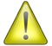 REMINGTON MODEL 700™ AND MODEL SEVEN™ RIFLES

PRODUCTS: Remington Arms Company, LLC (“Remington”) is voluntarily recalling Remington Model 700™ and Model Seven™ rifles with X-Mark Pro® (“XMP®”) triggers, manufactured from May 1, 2006 to April 9, 2014.

DESCRIPTION OF THE HAZARD: Remington has determined that some Model 700 and Model Seven rifles with XMP triggers could, under certain circumstances, unintentionally discharge. A Remington investigation has determined that some XMP triggers might have excess bonding agent used in the assembly process. While Remington has the utmost confidence in the design of the XMP trigger, it is undertaking this recall in the interest of consumer safety to remove any potential excess bonding agent applied in the assembly process.

HOW TO DETERMINE IF YOUR RIFLE IS SUBJECT TO THE RECALL: Only Model 700 and Model Seven rifles with XMP triggers are being recalled. To determine if your rifle is subject to this recall, you should take the following steps:

- Find the rifle’s serial number where the barrel meets the receiver. SEE GRAPHIC A
  - For a right-handed rifle, the serial number is located on a user’s left.
  - For a left-handed rifle, the serial number is located on a user’s right.

GRAPHIC A: HOW TO FIND YOUR SERIAL NUMBER.

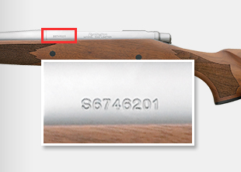

- Identify the serial number and provide it to Remington’s recall support team, either by entering it at xmprecall.remington.com or calling 1-800-243-9700 (Prompt #3 then Prompt #1) Monday through Friday, 9 a.m. to 5 p.m. EDT. You will be informed if your rifle is affected by this recall and supported with free resources to return the rifle for inspection and specialized cleaning.

- You may also determine if your rifle is subject to the recall by a visual inspection.

  - If the face of the trigger is ribbed (see Photo (1) below), your rifle does not have an XMP trigger and is NOT subject to this recall.

  - If the face of the trigger is smooth (see Photo (2) below), your rifle has an XMP trigger and IS subject to this recall – in which case you should immediately seek further assistance at xmprecall.remington.com or by calling 1-800-243-9700 (Prompt #3 then Prompt #1) Monday through Friday, 9 a.m. to 5 p.m. EDT.

NO recall (Photo 1) RECALL (Photo 2) 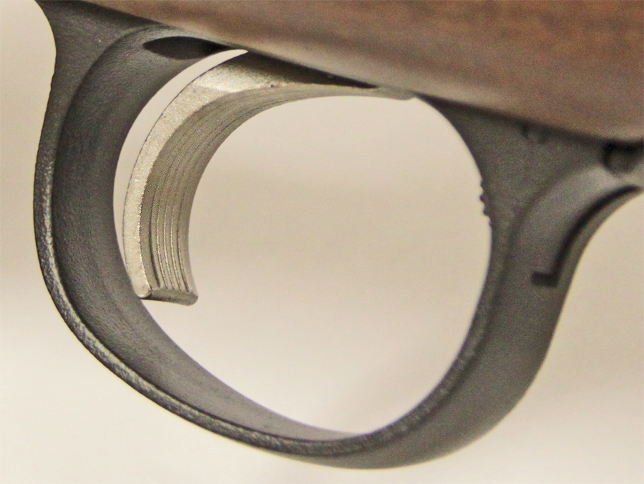 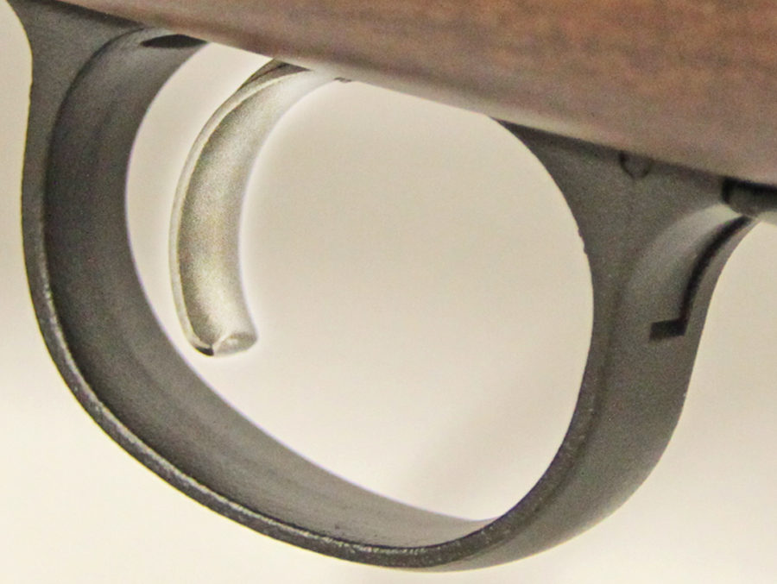

REMEDY/ACTION TO BE TAKEN: STOP USING YOUR RIFLE. Any unintended discharge has the potential to cause injury or death. Immediately cease use of recalled rifles and return them to Remington free of charge. Rifles will be inspected, specialty cleaned, tested, and returned as soon as possible, at no cost to you. DO NOT attempt to diagnose or repair recalled rifles.

TO PARTICIPATE IN THIS RECALL PROGRAM: For your safety, STOP USING YOUR RIFLE and immediately contact Remington.

To participate in the recall, please follow the instructions below:

STEP 1 Visit xmprecall.remington.com or call 1-800-243-9700 (Prompt #3 then Prompt #1) Monday through Friday, 9 a.m. to 5 p.m. EDT. You will be asked to provide your name, address, telephone number, and rifle(s) serial number.

STEP 2 Upon receipt of the information requested in Step 1, Remington will send you pre-paid shipping tags, boxes and written instructions. Remington will cover all related shipping, inspection, and cleaning charges. Please ONLY return your rifle with the designated shipping tags and boxes, as they are marked to expedite the rifle to a dedicated Remington facility.

VERIFICATION OF CORRECTIVE ACTION: Upon return of your rifle, you will note a punch mark on the bolt release (see Photo 3 below). This mark confirms your rifle has been inspected and specialty cleaned under this recall program.

Remington has also corrected the XMP trigger assembly process to eliminate this problem in rifles made after April 9, 2014. Rifles made after April 9, 2014 will also have a punch mark on the bolt release.

Even after your rifle has been inspected and repaired under this recall program, always follow the Ten Commandments of Firearm safety, printed below, whenever you handle any firearm.

The Ten Commandments of Firearms Safety
- Always keep the muzzle pointed in a safe direction.
- Firearms should be unloaded when not actually in use.
- Don't rely on your gun's safety.
- Be sure of your target and what's beyond it.
- Use proper ammunition.
- If your gun fails to fire when the trigger is pulled, handle with care.
- Always wear eye and ear protection when shooting.
- Be sure the barrel is clear of obstructions before shooting.
- Don't alter or modify your gun and have it serviced regularly.
- Learn the mechanical and handling characteristics of the firearm you are using.

PHOTO 3
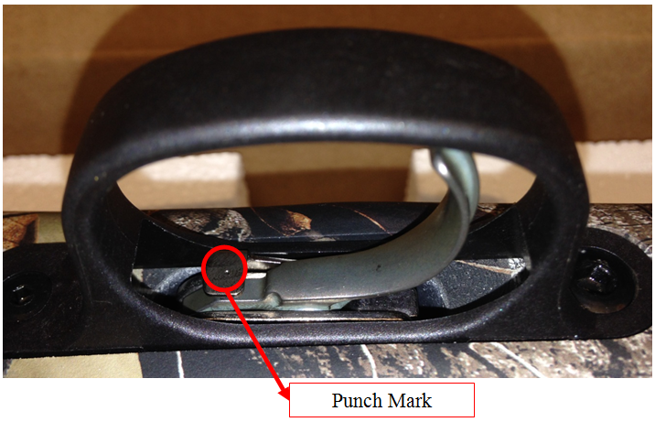

Remington is deeply sorry for this inconvenience, but we believe in safety first. It is imperative that Model 700 and Model Seven rifles subject to this recall are not used until they have been inspected and specialty cleaned by Remington.

The Remington team is committed to the quality and safety of its products.

