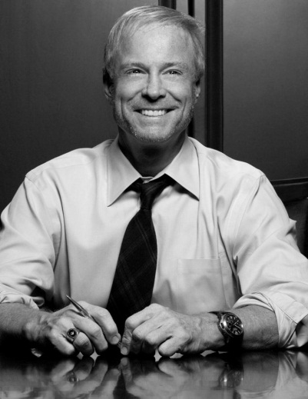
Russell B. Klein
Chief Executive Officer
American Marketing Association

Russell B. Klein is the incoming Chief Executive Officer of American Marketing Association (AMA). For more than 25 years, Klein has led marketing management, brand turnarounds and value creation for some of the best known consumer brands.

Prior to joining the AMA, Klein served as Chief Global Marketing Officer and a member of executive leadership teams at Arby's Restaurant Group, Inc., Burger King Brands, Inc., and 7-Eleven, Inc. Before that, Klein led a small private equity investment group and held senior posts at Dr Pepper/7Up Companies, Leo Burnett and Foote Cone & Belding Advertising, Inc. Throughout his career, Klein has helped build and strengthen some of the world’s foremost brands, including Gatorade, McDonald’s, Maytag, Keebler Cookies, Wilson Sporting Goods, Boston Market, Kimberly Clark’s Kleenex Brand, and United Airlines.

Known as a trailblazer, Klein has led marketing initiatives that fueled overall business growth and success. During his eight years at Dr Pepper/7Up Companies, Klein delivered $2.7 Billion in value creation and 600% combined return for shareholders. In addition, Klein has led a number of consumer marketing “firsts,” ranging from digital content innovation to the first-ever full product integration. These included Xbox original content for Burger King, sponsorship of free iPod video downloads, and the first Super Bowl commercial simulcast on mobile phones.

An award-winning marketer, Klein has achieved some of the industry’s highest accolades such as Grand Prix Titanium Lions at Cannes, Grand Effies and AMA Best New Product. Klein has been named to “top marketer” lists spanning three decades, including his Burger King body of work that was recognized by ADWEEK as “The Advertiser of the Decade” for the 2000’s. During that time, Interbrand named Burger King one of the “Top 100 Global Brands” for the first time in the company’s history and the Subservient Chicken micro‐site was named “Digital Campaign of the Decade” by Ad Age for the 2000’s.

Klein is a graduate of Harvard Business School Advanced Management Program and The Ohio State University where he received the Max Fisher College of Business Distinguished Alumnus Award. He is frequently invited to speak at both industry and academic symposiums and has participated in the distinguished lecture series at Harvard Business School.

