**Evaluation of Rice as a Method of Drying Out Waterlogged Cell Phones**

**DTJ Consulting**

**Outline –**

There is a wide public perception that a cell phone that has been accidentally immersed in water can be dried out by placing it in a sealed container of rice for a day or two. This report describes an experiment to evaluate the hygroscopic properties of rice, specifically its ability to remove water from a simulated cell phone.

**Summary –**

The evaluation demonstrates that rice does not work as an effective desiccant. In the experimental measurements, slightly more water was lost to evaporation simply by leaving the waterlogged device in an open room than by enclosing it in a container of rice.

**Water Ingress and Evaporation -**

When immersed, a real phone draws in water through the various openings and seams. The water is held in the interstices around the internal components and printed circuit boards, and is difficult to remove with passive methods. The only way that water is drawn from a wet phone at room temperature and pressure is by evaporation through convection, and this is limited by the small surface area of water exposed by the case seams and openings.

Other techniques for removing water include heat, forced air (with or without disassembly) and reduction of atmospheric pressure. Pressure reduction lowers the boiling point of water so it turns to vapor at room temperature.

**Methodology -**

Using a real cell phone for this experiment brings up a significant practical issue - a waterlogged phone tends to drip because of openings and seams in the case, which makes establishing the initial and subsequent weights of a wet phone problematic. For this reason, a phone simulator was devised for this experiment. The simulator is a plastic box with openings in the top. The openings total approximately 42 mm2, representative of the openings in several current phone designs that were examined.

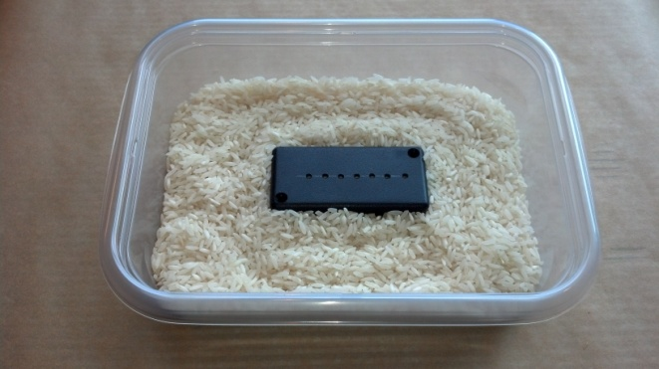 Inside is a small folded piece of paper towel, which at the beginning of the experiment is wetted with an accurately known weight of water. The weight of the water was chosen to be about 10% of the volume of a smart phone, as it is estimated that the internal spaces of a real phone total around 10% of its total volume.

**Results and Analysis –**

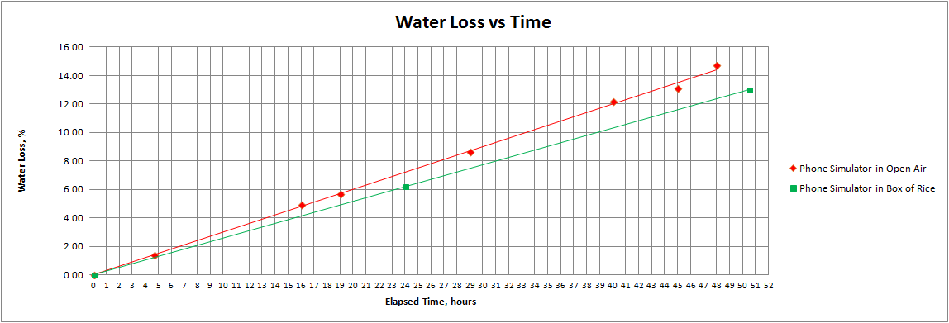

The chart shows the two parts of the experiment compared –

1) Water loss from the phone simulator as a percentage, before and after 24 hours and 50 hours in a sealed container holding approximately 1lb (440g) of Long Grain White Rice.

2) Water loss from the phone simulator as a percentage measured at intervals through a 48-hour period, exposed to the air in a room at approximately 21.5C.

In the first case (in a container of rice), approximately 6.3% of the water was absorbed after 24 hours, and about 12.5% after 48 hours (by interpolation from the graph above).



This experiment indicates a linear relationship between water weight loss and elapsed time.

**Design of Experiment –**

The phone simulator was used in two measurements. First, a known weight of water (around 5ml = 5 grams) was inserted into the simulator and the device was accurately weighed. Then the simulator was placed inside a container, which held approximately one pound of rice, and the airtight top of the container was fitted. After 24 hours, the container was opened, the simulator removed and reweighed, this was repeated after approximately 50 hours.

The second experiment set up the simulator in the same way, but the simulator was then left in the open air in a room at approximately 21.5C, and periodically reweighed over a 48-hour period.

The weight measurements were carried out using an electronic scale with a resolution of 10 milligrams. This is about 3% of the smallest weight differences encountered, sufficient to give a high confidence in the resolution of the results.

**Phone Simulator -**

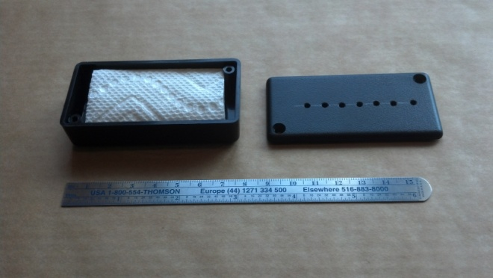

**Other Measurements –**

**Evaporation of water from an Open Container -**

To illustrate how the small openings in a phone case restrict the convection and subsequent evaporation, a small open-topped container of water with a surface area of 2000 mm2 was weighed and left exposed to the air in a room at approximately 21.5C.

In a 24 hour period, just over 30% of the water evaporated. This is much larger than the 6% or so that evaporated from the phone simulator in the same period. This illustrates that evaporation is speeded by convection, which is dependent on the surface area of water exposed.

**Water Content of Rice as Purchased -**

As a separate experiment, the water content of two types of rice as purchased from a store was measured. Approximately 100 g of each type of rice were accurately weighed, then placed in an oven at 65C for 100 minutes.

The sample of Extra Long Grain White Rice lost 4.3% of its weight and the Whole Grain Brown Rice lost 5.3% of its weight.

This simple evaluation indicates that rice is not strongly hygroscopic, as the weight of water after processing, manufacture and shipping is 4-5%.

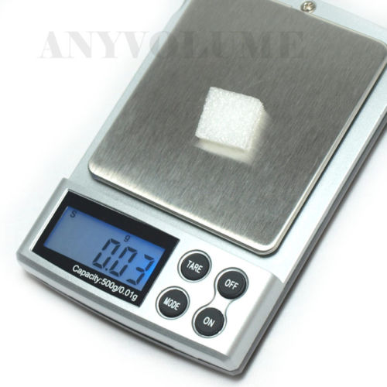

**The Effects of Water Ingress on Cell Phone Electronics**

High-density electronic components and assemblies such as those used in cell phones can be damaged by water ingress in several different ways. Because the circuit clearances are so small (often less than 100 microns), small areas of corrosion can bridge circuit connections and cause highly unpredictable failures.

The first type of corrosion to consider is galvanic – this means that dissimilar metals when immersed in water generate a small potential difference which quickly corrodes the metals involved. Metals and alloys present in cell phones include tin solder, brass, nickel, copper, gold, palladium and a wide range of others.

The second type of corrosion is electrolytic – because the cell phone contains a battery, anywhere there is a potential difference between conductors and water bridges the gap, then the water will undergo electrolysis producing hydrogen, oxygen and rapid corrosion. If the water is salty or contaminated, other very damaging chemical effects will destroy connections and components.

The printed circuit board assemblies contain a very high number of components and interconnects, but other devices such as the microphone, speaker, buttons and vibrator motor are very prone to moisture damage and are more difficult to seal completely.

In most cell phones, the circuitry is never completely switched off. A microprocessor or other logic is always active to detect the power button being pressed, which then enables other parts of the system to be powered on. Clock circuitry may also be active at all times.

In cell phones with internal batteries, immersion in water can cause uncontrollable operation of power circuits and other functions. If the power switch is still working, switching the phone off will at least reduce the portions of the circuitry that have active voltages. However electrolytic corrosion of the battery connections and power sequence circuitry will still occur.

For phones with removable batteries, removal of the battery will stop electrolytic corrosion although galvanic effects still continue.

Because corrosion is very damaging, manufacturers are increasingly applying a waterproof coating to the printed circuit board assemblies in cell phones. This is not a complete solution but will delay corrosion effects until the phone can be dried out.

Following accidental immersion, an effective drying method is necessary as soon as possible because corrosion happens within a short time and is often not reversible.

**References –**

A review of Corrosion and Environmental effects on electronics – Rajan Ambat, Technical University of Denmark [www.er-emergency.com/wp-content/uploads/2012/02/A-review-of-Corrosion-and-environmental-effects-on-electronics.pdf](http://www.er-emergency.com/wp-content/uploads/2012/02/A-review-of-Corrosion-and-environmental-effects-on-electronics.pdf)

Corrosion and Climatic Effects in Electronics – Hienonen/Lahtinen, VTT [www.vtt.fi/inf/pdf/publications/2007/P626.pdf](http://www.vtt.fi/inf/pdf/publications/2007/P626.pdf)