2015-2016 Solve for Tomorrow National Finalists
No. | State | City | School | Type | Description
1 | AL | Moulton | Lawrence County High School | HS | To save the local bee population, students designed bee hives that remove harmful pathogens from bees as they enter
2 | CA | Fremont | Mission Valley ROP/ James Logan High School | HS | Countering the cost to charge Electric Vehicles (EVs), students designed a solar charging station in the U.S. city with the most EVs
3 | CO | Aurora | Horizon Middle School | MS | Designed prosthetic enhancements for a local wounded veteran in the community
4 | FL | Oakland Park | Northeast High School | HS | In response to the number of deaths due to dangerous rip currents, the school created a rip current detection system
5 | MN | Anoka | Anoka Middle School for the Arts | MS | Used donated materials to construct tiny homes for the 1,000+ homeless youth in the community
6 | MO | Arnold | Ridgewood Middle School | MS | Reinforced cardboard to make stable classroom furniture for elementary school students with disabilities
7 | MS | Ellisville | South Jones Elementary | E | To counter the problem of cars running stop signs attached to school buses, students implement an alarm system that warns riders of oncoming traffic
8 | NC | Beulaville | East Duplin High School | HS | To mitigate invasive species in local waterways, students designed a boat washing system with an automated sensor
9 | NJ | Jersey City | Dr. Michael Conti School PS5 | MS | To reduce the amount of pollutants entering the school from idling cars, students created a magnetic window screen
10 | NY | Brooklyn | Brooklyn Technical High School | HS | Responding to deaths from car accidents, students created a smart watch app that warns of oncoming traffic
11 | OK | Wewoka | Wewoka Middle School | MS | Due to a need for clean water, students designed a cost-efficient water filtration system for a small community
12 | RI | East Greenwich | East Greenwich High School | HS | To counter the use of and litter from plastic materials, students engineered biodegradable plastics from renewable sources
13 | VA | Purcellville | Loudoun Valley High School | HS | Due to hikers getting lost or injured with no cell reception, students designed a wireless, solar-powered and weatherproof safety alert system for a hiking trail
14 | WA | Waterville | Waterville High School | HS | For snow and ice safety, students developed a solar-powered heated sidewalk system
15 | WI | Kenosha | Lincoln Middle School | MS | Due to rock salt harming the local ecosystem, students researched alternative methods to melt ice on the roads

2015-2016 National Finalists Map
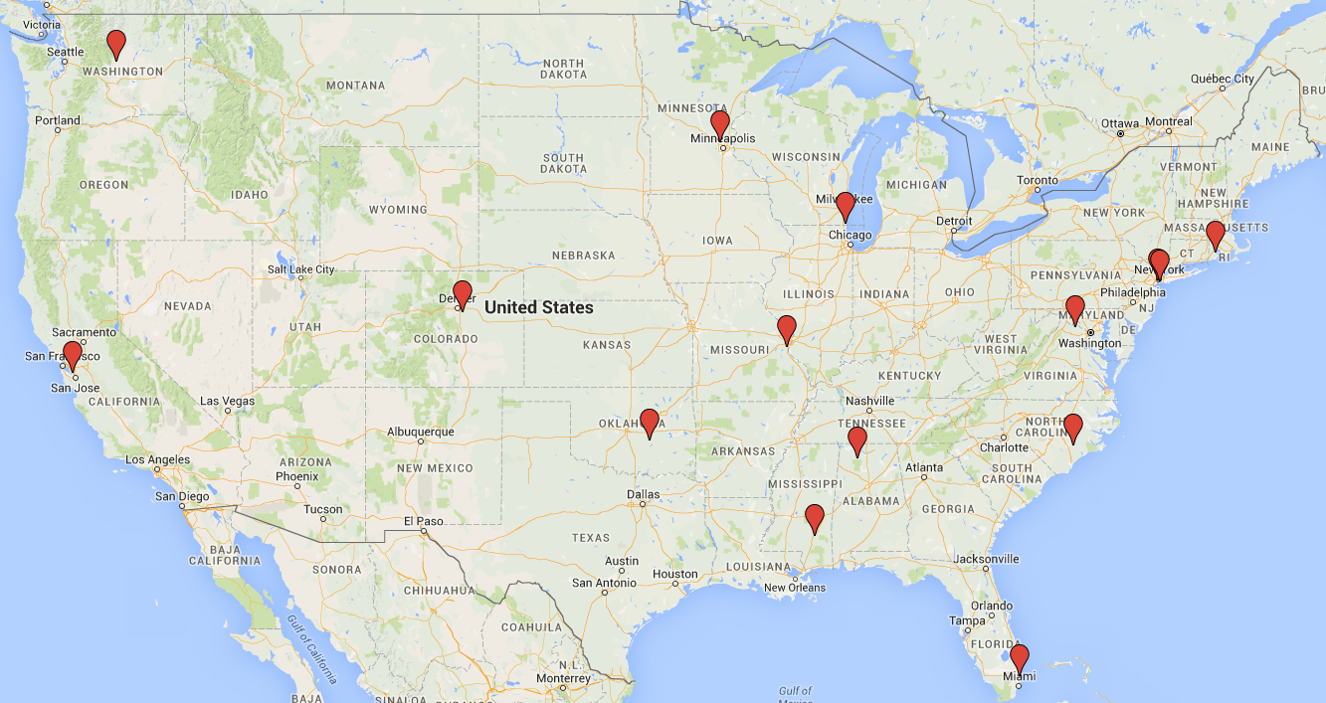
NJ
NY

