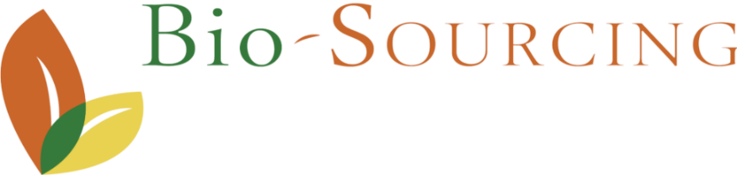
Changing the game of the biotherapeutics market

Expanding the human biotherapeutics market by revolutionizing drug delivery and patient access
Bio-Sourcing is reshaping the future of biologics through a disruptive bioproduction platform that enables high-volume, low-cost, and globally scalable manufacturing.
At the core of this platform lies a unique approach: therapeutic monoclonal antibodies are expressed directly in the milk of gene‑edited goats. Using advanced gene editing, cloning and other molecular biology techniques, these animals reliably produce recombinant antibodies at yields reaching grams per liter of milk. This naturally scalable system drastically lowers capital expenditure and production costs compared to the legacy cell culture system, while providing a sustainable and continuous supply of complex biotherapeutics.
On top of this massive advantage, antibodies secreted into milk co‑associate with exosomes, which act, when administered orally to a patient, as innate delivery vesicles, protecting the therapeutic molecule from degradation during gastrointestinal transit. This biological association enables a breakthrough previously considered impossible: the oral delivery of monoclonal antibodies with systemic bioavailability. The result is a transformative pathway toward self‑administered, comfortable, and accessible treatments for chronic diseases.
The platform's performance has already been extensively validated. Bio-Sourcing has successfully generated six monoclonal antibodies using this system, including four for a global pharmaceutical partner, supporting more than a decade of industrial maturation. Its latest molecule, adalimumab, has demonstrated preclinical similarity to the reference compound, Humira. The program is on track to enter clinical trials within the next twelve months, marking a major inflection point for the company.
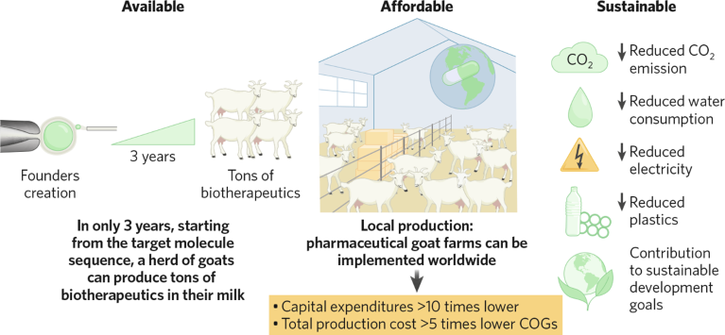
This technological foundation is reinforced by a robust intellectual property estate protecting each stage of the manufacturing chain—from gene editing and donor‑cell screening to purification methods and oral delivery mechanisms, as well as by proprietary know‑how accumulated through more than a decade of industrial partnership with a leading pharmaceutical company. It is further supported by a highly experienced and deeply specialized team whose combined expertise spans genetic engineering, bioproduct-tion, pharmaceutical development, regulatory strategy, and corporate growth, ensuring that the platform can advance efficiently from innovation to clinical and commercial execution.
Bio-Sourcing has received constant support and recognition from European Authorities : two Eurostars grants, an EIC Accelerator grant and a freshly received non-binding term sheet from EIC Fund for an equity investment of €8m as part of its ongoing €30m equity raise.
With strong momentum, a validated platform, and a pipeline entering clinical development, the company has the required assets to tackle a crucial phase of value creation by expanding biotherapeutic markets and creating new ones on a global scale.
March 2026
CEO – Dr. Bertrand Mérot – bertrand.merot@bio-sourcing.eu - CFO – Maxime Wallerand – maxime.wallerand@bio-sourcing.eu
Bio-Sourcing SA, headquarters Boulevard du Rectorat 27b, 4000 Liège, Belgium
www.bio-sourcing.com https://www.nature.com/articles/Bio-Sourcing/Best Natural Bioreactor

