**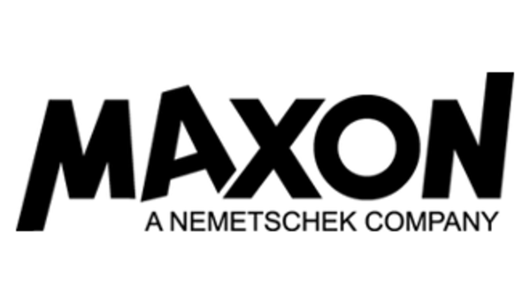**

**Media Alert…Media Alert…Media Alert**

**MAXON Announces Exhibitor Presence at 2019 NAB Show**

***Company to Showcase Latest Generation of Cinema 4D; Top Industry Artists Present Powerful Workflow Solutions for 3D Motion Graphics and VFX; Presentations Streaming Live on C4DLive.com***

**\_\_\_\_\_\_\_\_\_\_\_\_\_\_\_\_\_\_\_\_\_\_\_\_\_\_\_\_\_\_\_\_\_\_\_\_\_\_\_\_\_\_\_\_\_\_\_\_\_\_\_\_\_\_\_\_\_\_\_\_\_\_\_\_\_\_\_\_\_\_\_\_\_\_\_**

LAS VEGAS, NAB 2019 – [SL#6324](https://nab19.mapyourshow.com/8_0/floorplan/?hallID=D&selectedBooth=SL6324) – [Maxon](https://www.maxon.net/en-us/), the industry-leading developer of professional 3D modeling, animation and rendering solutions, is pleased to announce details of its exhibitor participation at the NAB Show, “…the world's comprehensive convention encompassing the convergence of media, entertainment and technology.” Maxon returns to NAB to showcase its flagship professional 3D software solution [Cinema 4D](https://www.maxon.net/en-us/products/cinema-4d/overview/), and the power and versatility the technology delivers to next generation content creators. The NAB Show is held April 6-11, 2019 at the Las Vegas Convention Center.

**Maxon Press Luncheon**  
Maxon reprises its annual “First Day of NAB” press luncheon on Monday, April 8. This year, Maxon’s new CEO, David McGavran, will unveil the company’s near-term strategic goals to be more globally-focused, the latest news, and how Cinema 4D solutions and innovation continue to meet the needs of today’s 3D content creators.

*[Note: This is an invitation-only event. Members of the press interested in attending, please contact Vicky Gray-Clark,* [*vicky@ambientpr.com*](mailto:vicky@ambientpr.com),*indicating name and media outlet for consideration.]*

**Maxon Exhibitor Booth Highlights**

At the Maxon booth, #SL 6324, guest artists will demo Cinema 4D Release 20. The latest version of the software marks a huge leap in technology with high-end tools and features for VFX and motion graphics artists, including a node-based material system, new volume-based modeling tools, a very powerful CAD import and a major expansion of the MoGraph toolset. Cited by artists at top production studios worldwide for its intrinsic flexibility for conceptualizing and designing projects, the legendary MoGraph toolset in Cinema 4D was honored earlier this year with a Scientific and Technical Academy Award® for its significant impact on filmmaking.

Maxon promises to deliver an incredible show experience to those attending NAB and those unable to attend in person. Each day of the show ***super star*** artists from the motion graphics and visual effects community will present on the Maxon exhibit booth main stage. They will be sharing techniques, behind the scenes content and valuable insights from real world projects to illustrate the capabilities in Cinema 4D that have inspired the creation of some of today’s most celebrated film, broadcast, multimedia and visualization projects.

**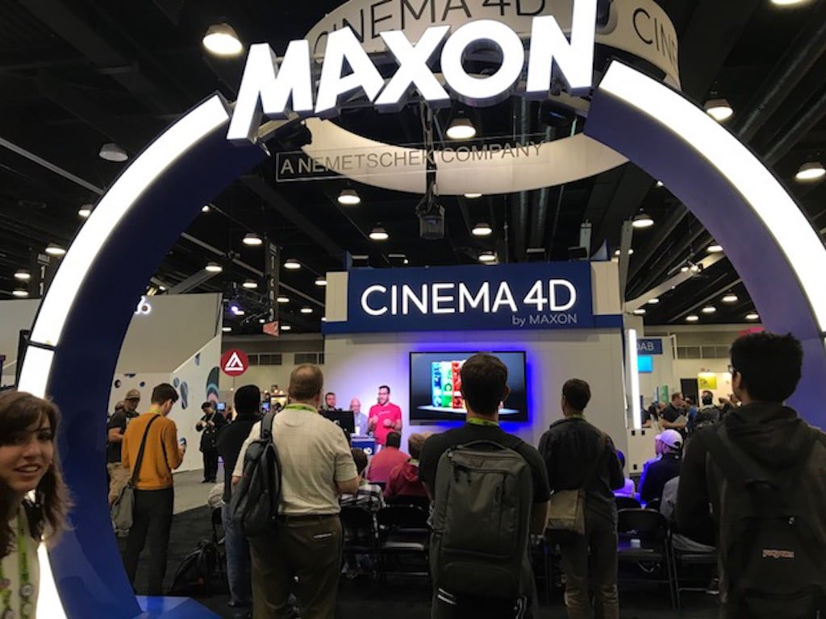**

**Guest Artist Presenters**

The stellar line-up of guest artists scheduled to present at the Maxon NAB Show booth includes:

* Mike Winkelmann aka Beeple – [Beeple](https://www.beeple-crap.com/)
* Andrew Kramer – [Video Copilot](https://www.videocopilot.net/)
* EJ Hassenfratz – [Eyedesyn](https://www.eyedesyn.com/)
* Barton Damer – [Already Been Chewed](https://www.alreadybeenchewed.tv/)
* Nick Campbell – [Greyscalegorilla](https://greyscalegorilla.com/)
* Ken Carlson – [Big Machine](https://www.bigmachine.tv/)
* Brett Morris – [Ranger & Fox](https://www.rangerandfox.tv/)
* Casey Hupke – [Casey Hupke](http://www.xcaseyx.com/)
* Michael Rosen – [Samplistic](http://www.samplistic.com/)
* Chad Ashley – [Greyscalegorilla](https://greyscalegorilla.com/)
* Lorcan O’Shanahan – [Datalust](http://lorcanoshanahan.com/)
* Thomas Brown – [Vessel Studios](https://vesselstudios.com/)
* Andy Tagliasacchi – [Freelance Artist](https://vontaglia.com/)
* Chris Schmidt – [Rocket Lasso](https://rocketlasso.com/)
* Chris Priddy – [Fiveten Giant](https://www.fivetengiant.com/about)
* Casey Latiolais – [State of Secrecy](https://caselat.com/state-of-secrecy)
* Nick DenBoer – [Smearballs](http://www.smearballs.com/)
* Bryan Coleman – [Bryan Coleman](https://www.bryancoleman.com/)

All presentations will stream live during NAB on [C4DLive](http://www.c4dlive.com/) and be archived after the show on [Cineversity](https://www.cineversity.com/). Full details on guest artist presenters and streaming schedules is currently available [here](http://www.c4dlive.com/).

**Maxon Around the 2019 NAB Show**

During NAB, Maxon is sponsoring a number of educational and networking events, as follows:

[**Post|Production World**](https://www.nabshow.com/education/training-programs/post-production-world) **– Saturday, April 6 – Tuesday, April 9, 2019,** [**Las Vegas Convention Center**](https://www.lvcva.com/)

[Post|Production World](https://www.nabshow.com/education/conference/post-production-world) at NAB Show offers advanced training offerings for post and production professionals from top industry instructors geared to content creators and designers including TV, film and video editors, producers, directors, graphic artists, motion graphics designers and new media specialists. Maxon certified trainer, [Thanassis (Noseman) Pozantzis](http://noseman.org/), will offer several sessions focused on Cinema 4D solutions including:

# “[In-Depth: Maxon Cinema 4D MoGraph Fundamentals”](https://nab19.mapyourshow.com/8_0/sessions/session-details.cfm?ScheduleID=199)

Saturday, April 6 • 3:30 PM - 6:30 PM -- Location: [S229](https://nab19.mapyourshow.com/8_0/floorplan_link.cfm?show_id=NAB19&alt_entry=true&curr_pri=facility&hallid=G&booth=S229&object_type=room)

* [“Bootcamp: Cinema 4D for the Absolute Beginner: From Lite to Studio”](https://nab19.mapyourshow.com/8_0/sessions/session-details.cfm?ScheduleID=144)

Sunday, April 7 • 9:00 AM - 11:30 AM -- Location: [S228](https://nab19.mapyourshow.com/8_0/floorplan_link.cfm?show_id=NAB19&alt_entry=true&curr_pri=facility&hallid=G&booth=S228&object_type=room)

* [“Cinema 4D MoGraph Fields in Action: 3D Layers for 4D Effects”](https://nab19.mapyourshow.com/8_0/sessions/session-details.cfm?ScheduleID=149)

Monday, April 8 • 2:00 PM - 3:15 PM -- Location: [S228](https://nab19.mapyourshow.com/8_0/floorplan_link.cfm?show_id=NAB19&alt_entry=true&curr_pri=facility&hallid=G&booth=S228&object_type=room)

* [“Understanding VDBs and Modeling with Cinema 4D Volumes”](https://nab19.mapyourshow.com/8_0/sessions/session-details.cfm?ScheduleID=260)

Tuesday, April 9 • 3:30 PM - 4:45 PM -- Location: [S228](https://nab19.mapyourshow.com/8_0/floorplan_link.cfm?show_id=NAB19&alt_entry=true&curr_pri=facility&hallid=G&booth=S228&object_type=room)

[**Broadcast Education Association Annual Convention**](https://www.beaweb.org/conv/about-beavegas/)**– Saturday, April 6 – Tuesday, April 9,** [**Las Vegas Westgate**](https://www.westgateresorts.com/hotels/nevada/las-vegas/westgate-las-vegas-resort-casino/)

The annual Broadcast Education Association convention is co-located at NAB and features more than 250 sessions, workshops and research geared to media production. Maxon returns to BEA and will host a booth to showcase how Cinema 4D graphics and animation education solutions benefit broadcast media industry educators, students and professionals seeking to advance their professional 3D skill sets.

[**MoGraph Meetup**](https://www.eventbrite.com/e/nab-2019-mograph-meetup-beerhaus-tickets-56559430780) **– Sunday, April 7, 5:30 – 10:00 p.m.,** [**Beerhaus**](https://www.theparkvegas.com/en/restaurants/beerhaus.html)

The must-attend MoGraph Meetup, entering its second year, welcomes members of the motion graphics community to an inspired evening of hanging out and camaraderie with industry peers. Maxon is an event sponsor along with [School of Motion](http://schoolofmotion.com/), [Motion Hatch,](https://motionhatch.com/) [Greyscalegorilla](http://greyscalegorilla.com/" \t "_blank), [Video Copilot](http://videocopilot.net/), [Motion Array,](https://motionarray.com/) [Action VFX,](https://www.actionvfx.com/) [aescripts + aeplugins](http://aescripts.com/" \t "_blank), and [Red Giant](https://www.redgiant.com/). Free to attend, [RSVP](https://www.eventbrite.com/e/nab-2019-mograph-meetup-beerhaus-tickets-56559430780?invite=&err=29&referrer=&discount=&affiliate=&eventpassword=) required.

[**MediaMotion Ball**](http://www.mediamotionball.com/index.html)**– Monday, April 8, 5:30 – 10:00 p.m.,** [**SLS Las Vegas Hotel**](https://slslasvegas.com/)

The MediaMotion Ball, produced by volunteer organizations International Media Users Group (IMUG) and the AE-List, heads into its 22nd year at NAB as the premier and longest-running annual user group and networking event for post-production, production, motion graphics, and 3D industry professionals. Maxon reprises its sponsorship role as the exclusive provider of fine wines for the dinner event.

**Maxon Exhibit Booth Hours**  
The Maxon booth #SL 6324 will be open during 2019 NAB Show exhibit hours, as follows:

**Location**[Las Vegas Convention Center](http://www.lvcva.com/who-we-are/our-facilities/las-vegas-convention-center/)  
3150 Paradise Road  
Las Vegas, NV 89109

### Exhibit Hall Hours

Monday, April 8 | 10 a.m. - 6 p.m.  
Tuesday, April 9 | 9 a.m. - 6 p.m.  
Wednesday, April 10 | 9 a.m. - 6 p.m.  
Thursday, April 11 | 9 a.m. - 2 p.m.

**Onsite Media Briefing**  
To schedule a media briefing opportunity with David McGavran during NAB, please contact Vicky Gray-Clark, Ambient PR, (408) 318-1980, [vicky@ambientpr.com](mailto:vicky@ambientpr.com), or feel free to stop by the Maxon booth # SL6324.

**Maxon Web Resources**

Additional information on Maxon can be obtained as follows:

[Website](http://www.maxon.net/)

[YouTube](http://www.youtube.com/user/MaxonC4D)

[Facebook](https://www.facebook.com/maxon3d)

[Instagram](https://www.instagram.com/maxonc4d/)

[Twitter](https://twitter.com/maxon_de)

[Cineversity](https://www.cineversity.com/)

[XING](https://www.xing.com/companies/maxoncomputergmbh)

[LinkedIn](http://www.linkedin.com/company/791366)

All trademarks contained herein are the property of their respective owners.

# # #

**Maxon Media Contact**Vicky Gray-Clark  
Ambient PR  
(408) 318-1980, vicky@ambientpr.com